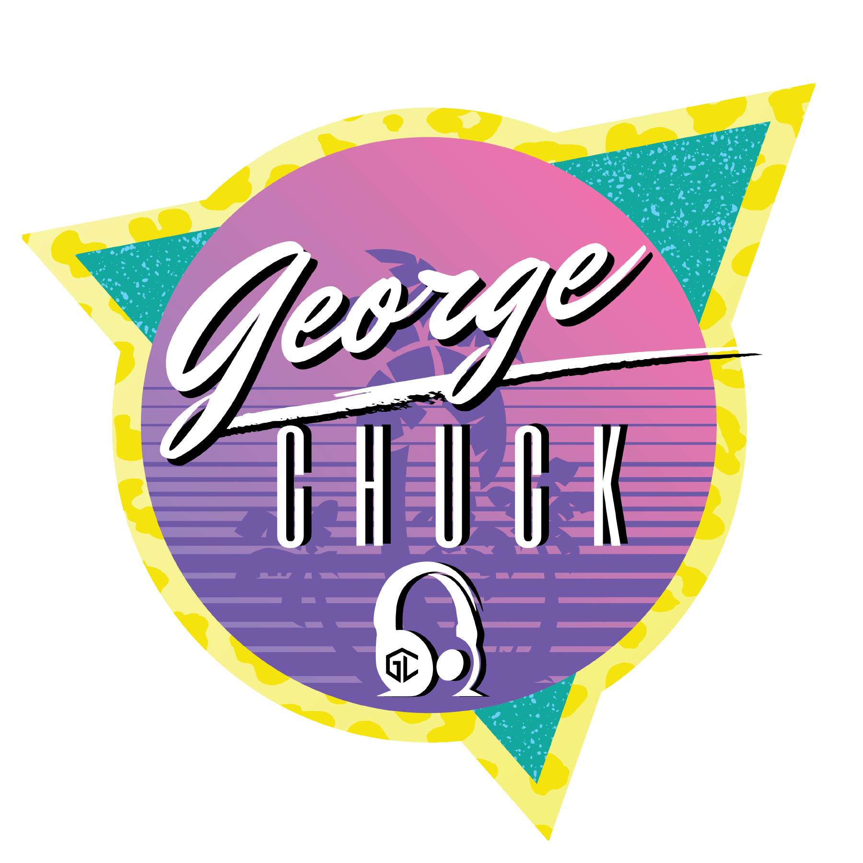

|  |  |
| --- | --- |
| **COUPLE'S NAMES** |  |
| **EVENT DATE** |  |
| **LOCATION** |  |
| **PRIMARY CONTACT** |  |
| **Wedding Colors** |  |

|  |  |  |  |
| --- | --- | --- | --- |
| **Services: Type “Yes” or “No” next to each item.** | | | |
| (Yes/No) | **DJ Reception** |  | **Wedding Monogram** |
|  | **Ceremony Audio** |  | **Motion Lighting** |
|  | **Dancing On A Cloud** |  | **Uplighting** |
|  | **Cold Sparklers** |  | **Photo Booth** |

| TIME | EVENT | SONG/ARTIST | NOTES |
| --- | --- | --- | --- |
|  | Ceremony Prelude |  | You can edit this timeline as you see fit. Reorganize the events to your liking. |
|  | Bridal Party Processional |  |  |
|  | Bride Processional |  |  |
|  | Sand/Unity Ceremony |  |  |
|  | Recessional |  |  |
|  | Cocktail Hour |  | You can provide a link to an apple/spotify playlist for this, if you like. |
|  | Grand Entrance |  |  |
|  | Couple’s first dance |  |  |
|  | Bride dances with father |  |  |
|  | Groom dances with mother |  |  |
|  | Dinner Hour |  |  |
|  | Cutting of the cake |  |  |
|  | Toast |  |  |
|  | Dance Floor |  |  |
|  | Bouquet and garter toss |  |  |
|  | Grand Exit |  |  |

**Please DO play these songs:**

These songs are special to the Bride and Groom and/or their family and friends, and must be played during the Open Dance portion of the reception.

|  |  |
| --- | --- |
| **SONG** | **ARTIST** |
|  |  |
|  |  |
|  |  |
|  |  |
|  |  |
|  |  |

**DO NOT play these songs:**

Under NO circumstances, even by guest request, should these songs be played:

|  |  |
| --- | --- |
| **SONG** | **ARTIST** |
|  |  |
|  |  |
|  |  |
|  |  |
|  |  |
|  |  |

**General Music Styles we Like/Dislike:**

|  |  |  |
| --- | --- | --- |
| **MUSIC STYLE** | **WE LIKE IT** | **WE DISLIKE IT** |
| Country |  |  |
| Pop |  |  |
| Oldies (50s and 60s) |  |  |
| Classic Rock (60s and 70s) |  |  |
| 80s Rock / Pop |  |  |
| Rap |  |  |
| R&B |  |  |
| Heavy Metal |  |  |
| Classical |  |  |
| Latin |  |  |
| Folk |  |  |
| Jazz |  |  |
| Alternative Rock |  |  |
| Big Band |  |  |
| Christian |  |  |
| Disco |  |  |
| Hip Hop |  |  |
| Reggae |  |  |
| Punk |  |  |
| Techno |  |  |

**General Artists We Like/Dislike:**

|  |  |  |
| --- | --- | --- |
| **ARTIST / GROUP** | **WE LIKE THEM** | **WE DISLIKE** |
|  |  |  |
|  |  |  |
|  |  |  |
|  |  |  |
|  |  |  |

**General DJ Behavior and Our Preferences:**

|  |  |  |
| --- | --- | --- |
| **BEHAVIOR** | **DO IT** | **DON’T DO IT** |
| Bring dance props (hats, etc) |  |  |
| Encourage guests to participate |  |  |
| Single out guests who aren’t dancing |  |  |
| Joke / laugh / talk during Open Dance |  |  |
| Be humorous when announcing events |  |  |
| Be serious / professional when announcing events |  |  |
| Wear a tuxedo |  |  |
| Take requests from guests |  |  |
| Take requests from Bridal Party |  |  |
| Smoke or drink alcohol |  |  |
|  |  |  |
|  |  |  |

**Additional Notes:**